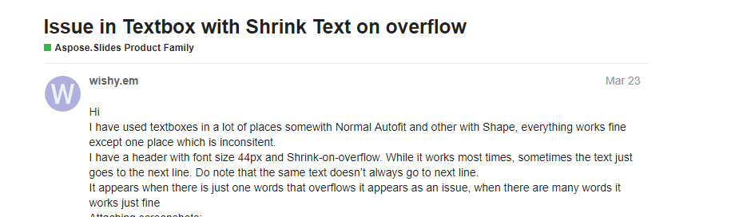

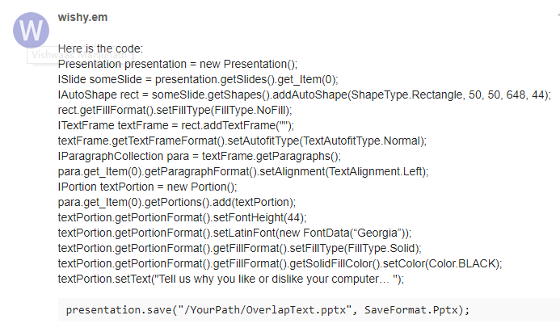





https://forum.aspose.com/t/issue-in-textbox-with-shrink-text-on-overflow/174021/8